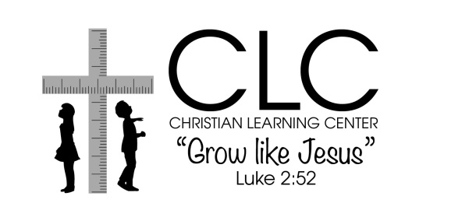
1717 4th Ave.
PO Box 1264
Canyon, TX 79015
(806)655-3246
clc@christianlearningcenter-canyon.com

RE-ENROLLMENT or UPDATE INFORMATION
SUMMER 2022

Child’s Name: First______________________ M.I. ____ Last:________________________DOB:____________
Program (circle): Infant (0-18m) Toddler-3yr. PreK-3: OR PreK-4: School-age:
M-F *M-F * M-F * M-F
(only option) *M W F *M W F *M W F
*T TH *T TH * T TH

*Enrolled Days of Week are based on current enrollment availability. Please circle your preferred choice.
Parent/Guardian 1 Name:________________________________________________________________
Home Address:_________________________________________________________________________
Mailing Address:________________________________________________________________________
Email Address:_____________________________Occupation/Employer:___________________________
Phones: home: ____________________ cell:_____________________ work: _______________________
Cell phone service provider (for texting purposes):_______________________
Marital Status: [ ] Married [ ] Single [ ] Divorced [ ] Separated [ ] Widowed [ ] Other__________
Relationship to Child: [ ] Mother [ ] Father [ ] Grandparent [ ] Foster Parent [ ] Other ___________
Mark all that apply: [ ] Child Lives With [ ] Emergency Contact [ ] Authorized Pick up

Parent/Guardian 2 Name:________________________________________________________________
Home Address:_________________________________________________________________________
Mailing Address:________________________________________________________________________
Email Address:_____________________________Occupation/Employer:___________________________
Phones: home: ____________________ cell:_____________________ work:__ _________________
Cell phone service provider (for texting purposes):_______________________
Marital Status: [ ] Married [ ] Single [ ] Divorced [ ] Separated [ ] Widowed [ ] Other________
Relationship to Child: [ ] Mother [ ] Father [ ] Grandparent [ ] Foster Parent [ ] Other _________
Mark all that apply: [ ] Child Lives With [ ] Emergency Contact [ ] Authorized Pick up

I would like to receive information on First Baptist Church: Yes Please No Thank You

List any changes for additional emergency contacts and authorized pick up:

Add or Remove or Make Changes to this person (circle one)
First Name: ______________________ M.I. _____ Last Name: __________________________________
Address: _____________________________________________________________________________
Phones: home: ___________________ cell: ________________________work: ______________________
Relationship to Child: _______________________ [ ] Emergency Contact [ ] Authorized to pick up child

Signed:___________________________________ Date:_______________________________

